



***“Since 1996 you can get it straight from Twisted Wrench”***

Newsletter #2 11/12/2012

***“Automotive technology has made cars almost worry free”!***

New vehicles have become a lot more reliable. It is easy to think your car is always “ready to go!” In most cases it will be ready. A lot of thought has gone into how a vehicle will handle cold weather in winter. Some cars like Subaru are designed with Burlington Vermont weather in mind. Subaru’s have all wheel drive, but without proper tires it would get stuck in the snow. The same idea applies to all cars in winter. They are designed for cold weather but without the proper fluids etc, they will have problems.

Twisted Wrench knows to check even the newest vehicles to insure their readiness for the winter season. All vehicles need good tires, proper inflation pressure, coolant that will not freeze, washer fluid that will not freeze, lights that work, good wipers etc, etc… Not only does the coolant need to not freeze, but it has to be the correct coolant that the vehicle requires to be able to function as designed. Today’s modern vehicles do a lot of thinking and calculating for the driver, so you can just drive and enjoy your car! Do not allow a situation to occur that your car is not able to keep track of, by putting the wrong products in it. Maybe someday cars will monitor tire tread and coolant freezing protection, but for now Twisted Wrench can keep track of the complicated ever changing world of automobiles, to insure your car has what it needs to do its best this winter and for years to come.

Let Twisted Wrench help, schedule your next appoint online at [www.twistedwrenchvt.com](http://www.twistedwrenchvt.com) or email us [twistedwrenchvt@gmail.com](mailto:twistedwrenchvt@gmail.com) our office number is (802) 660-0838 or (888) 9 WRENCH! Please also look for us on FaceBook.

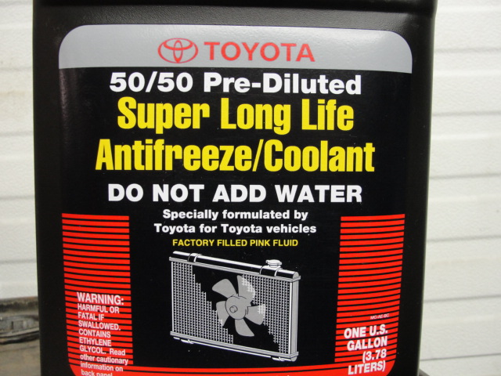 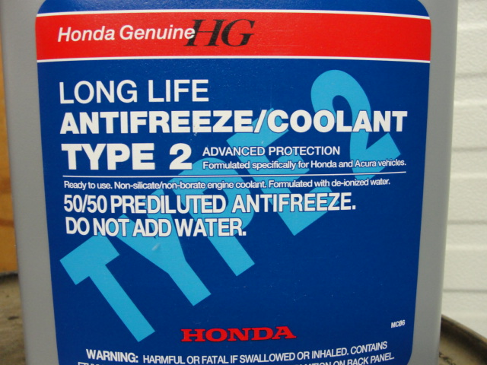 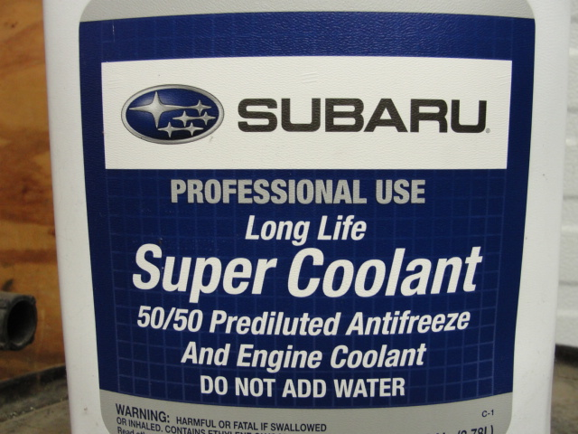

*“Which Coolant does your car use”?*

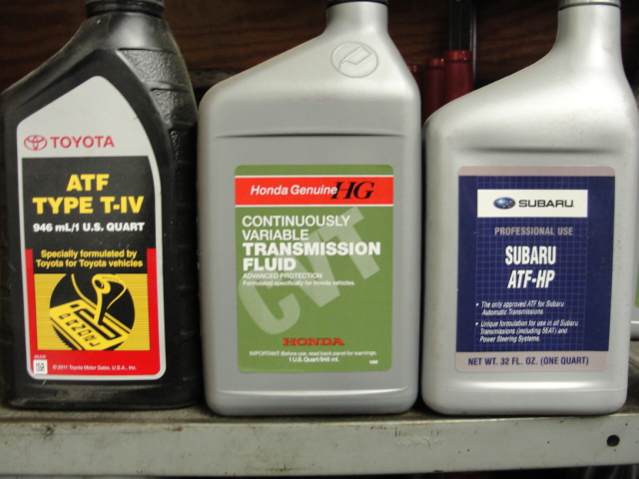

*“Where do you put ATF fluid in your car”?*

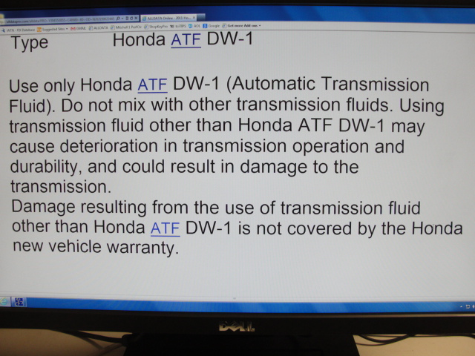

*“Don’t forget to read the fine print”!*

***“Since 1996 you can get it straight from Twisted Wrench”***