



***“Since 1996 you can get it straight from Twisted Wrench”***

Newsletter #3 12/12/12

I think our customers must like their mechanics to be fat! This time of year we have so many people bringing in baked good for us it’s amazing. Cookies, cakes, chocolates, fudge, you name it. One year a good customer of ours brought in microwave popcorn. He put it on the counter and said “Happy Holidays. I don’t bake, so here’s your popcorn.” Not quite chocolate chip cookies, but fewer calories. With Winter here maybe the guys in the shop need the calories anyway, it is a lot of work putting snow tires on cars all day. So thanks to everyone who brings us baked goods and sends us cards, it is a nice feeling that so many of you think to do that for us.

Everyone here at Twisted Wrench would like to say happy holidays and thank all of our customers for making this another great year. Without all of you we would not be where we are today. For those of you that remember when Jim started Twisted Wrench down the street in 1996, you know we have come a long way, and we are very thankful for the loyalty so many of you have given to us over the years. We intend to continue to impress you. In that regard we have made some changes over the course of the year to try to improve the services we provide all of you. While we have been a used car dealer for several years, we started going to the out of state auto auctions, and sold nearly 40 cars to our customer this year. Now that we have gotten our feet wet we hope to sell more cars in 2013. Early in the coming year you should start seeing our cars displayed on Lime Kiln road for better exposure. We don’t get a lot of drive by traffic on Ethan Allen Drive. We decided to expand our Toyota line to include Scion and Lexus (Toyota makes both of these brands) and we added Volvo to our list of cars we specialize in. Many of you have asked us to work on the other cars you own, the ones we do not specialize in. Since the customer is always right we have decided to do this for you, our existing customers. So if your other car is a Buick we can help you. We have two new technicians who are well versed in other makes and models. Don’t worry though; we will still be focusing on our core line of cars. Another change you may have noticed is our new sign. Jim designed the new sign and installed it when it was completed. I can’t imagine what it would have looked like if I had installed it. I would have put it in upside down or something. That may actually have been eye catching, maybe we should do that. I will see what Jim thinks about my brilliant idea.

Everyone here had a wonderful Thanksgiving, and we hope all of you did as well. We would like to wish you all a safe and happy Christmas, Kwanzaa, Hanukkah, Winter Solstice, New Years Eve, or whatever holidays you celebrate. This assumes the Mayans are not correct of course. I gave my wife her Christmas present early just in case.

Peace.

Eric and the Twisted Wrench Team.

**“The New Sign”**

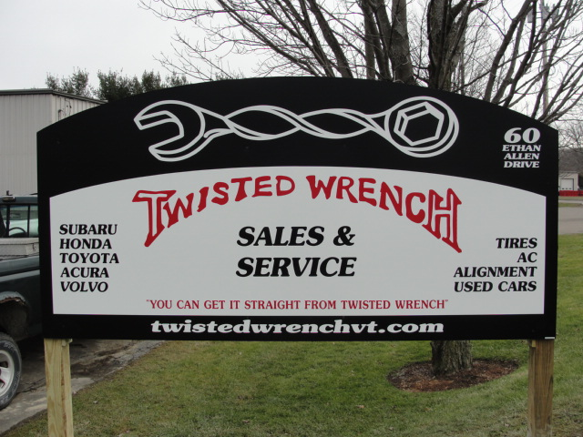

See more details on our website [www.twistedwrenchvt.com](http://www.twistedwrenchvt.com) or find us on FaceBook.

Call 660-0838 or email us [twistedwrenchvt@gmail.com](mailto:twistedwrenchvt@gmail.com)

***“Since 1996 you can get it straight from Twisted Wrench”***