



***“Since 1996 you can get it straight from Twisted Wrench”***

Newsletter #1 10/12/2012

So much has been happening, we are not sure we can write about all of it. Twisted Wrench has been growing bigger with the customers in mind providing a large comfortable waiting room including complimentary Wi-Fi, coffee, tea, and hot chocolate. We also have a convenient shuttle service that can make servicing your vehicle that much easier. The friendly staff here at Twisted Wrench is truly experts in all aspects of auto repair in Burlington Vermont area, specializing in your Subaru, Honda, Toyota, and Acura. This specialization will get you back on the road in most cases the same day!!!!

Twisted Wrench has invested a great deal of time and energy to make your visit to our business informative, efficient and complete. We keep track of your vehicle for you. We prioritize and explain your service options. Our experts figure out what makes the most sense for your care and contact you to discuss everything ***first*** so there will be no surprises when you get your bill. We are dedicated to continue to grow to accommodate all your different needs that may come up in the future for automotive repair in Burlington Vermont area.

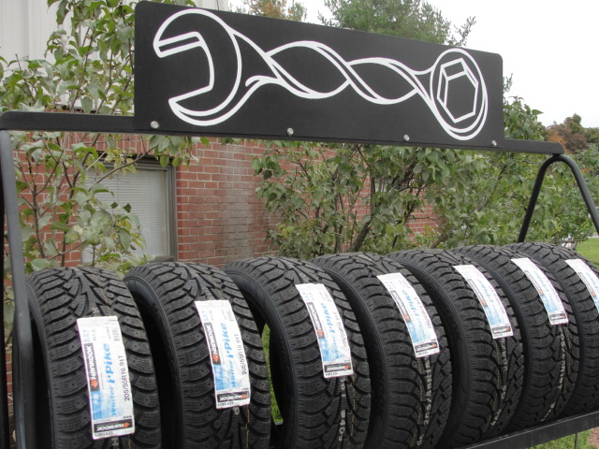

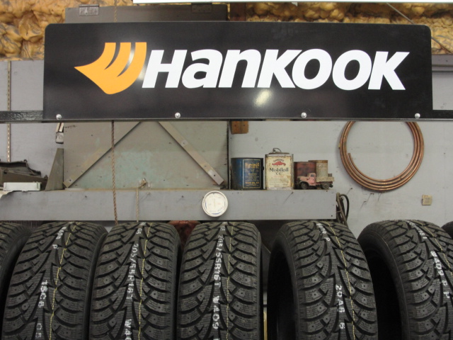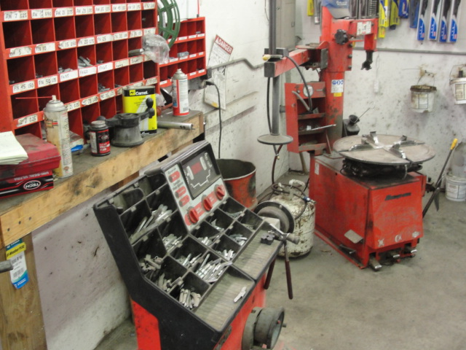

**Snow tires & Alignment:**

Winter is coming soon, snow on Mount Mansfield, and frost on the windshield. The time has come for you to start planning to change over to your winter tires. Let Twisted Wrench help, if you are planning on 4 new tires this winter check out Twisted Wrench’s FREE ALINGMENT when you purchase 4 new tires and mount and balance them. See more details on our website [www.twistedwrenchvt.com](http://www.twistedwrenchvt.com) or find us on FaceBook. Alignment ensures your car will handle better and your tires will last longer. Stay ahead of the snow drifts and be ready for slippery driving conditions. Call 660-0838 or email us [twistedwrenchvt@gmail.com](mailto:twistedwrenchvt@gmail.com) to have the best traction and handling this winter with new tires and a FREE ALIGNMENT from Twisted Wrench.

**“The Alignment Machine”**

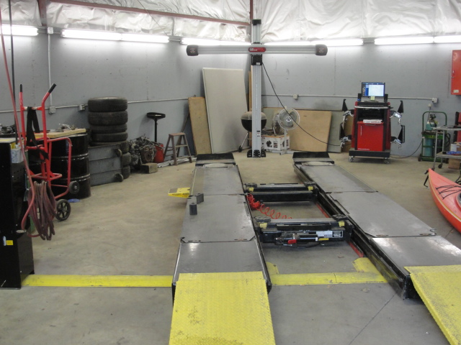

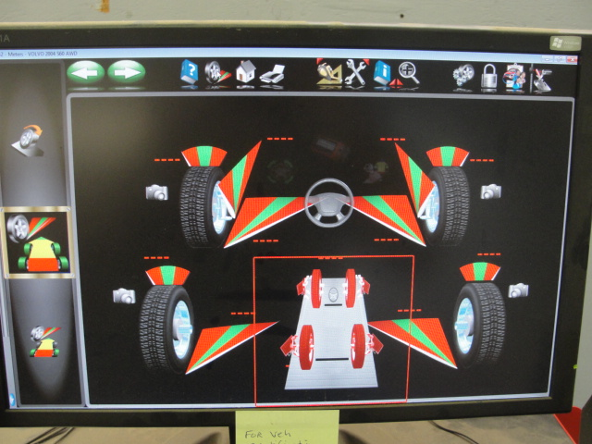

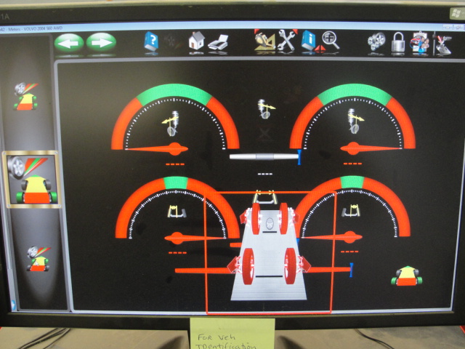

***“Since 1996 you can get it straight from Twisted Wrench”***